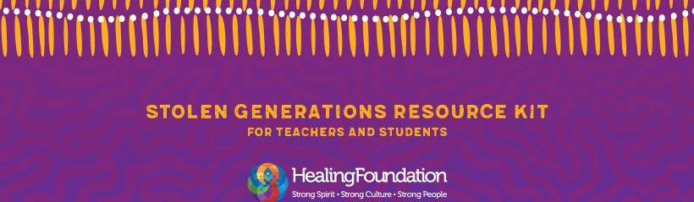

School grant funding Expression of Interest form
March 2020
In light of the COVID-19 pandemic, we understand that schools across the country may be revising their class timelines and learning arrangements.
Schools can still apply for cash grants to support activities from the Stolen Generations Resource Kit for Teachers and Students. The grants can assist teachers to find creative solutions that bring lesson plans to life as schools move to online learning.
If you applied for a book bundle prior to 20 March 2020 and your application is successful, you will still receive these books but please note there may be a shipping delay.
Schools are encouraged to apply for grants. Book bundle applications will be on hold until later in the year when a new round of expressions of interest will open.

School name:
Contact person:
Media contact:
Address:
Suburb: |  | State:
Postcode: |  | ABN:
Phone: |  | Mobile:
Email:

Attach ABN registration extract from the Australian Business Register http://abr.business.gov.au

More than 13,000 teachers and students across Australia have already accessed The Healing Foundation’s Stolen Generations Resource Kit for Teachers and Students, helping young people to better understand the history of Stolen Generations survivors and the impact of intergenerational trauma.

This year we are encouraging schools and teachers to run activities that complement the lesson plans from the kit.

DETAILS OF EXPRESSION OF INTEREST
Please provide a brief description of the activity/activities you will be conducting from the Stolen Generations Resource Kit for Teachers and Students. Please include how you will involve one or more Stolen Generations survivors in your activity/activities.

Date of activity:
Location of activity: | State:

This year to help schools deliver materials from the lesson plans, we have created Primary and Secondary School book bundles that include Aboriginal and Torres Strait Islander literature from the recommended reading lists in the kit. Would you like to apply for a book bundle?

Yes No

And if so, which book bundle would you like to select. You can select both if you want.

Primary School book bundle (Grade Prep – 6)

Secondary School book bundle (Years 7 – 9)

Please note if you applied for a book bundle prior to 20 March 2020 and your application is successful, you will still receive these books but there may be a shipping delay.
Book bundle expressions of interests submitted after 20 March will be held until a new round of expressions of interest will open later in the year. The cash grant component will still be available in the current round of funding.

How will your activities ensure that children are safe and supported? Please outline how your project will be in line with the working with children checks in your jurisdiction.

What materials will you provide from the activities, i.e. photos, videos? This material needs to be included with your final report due 30 September 2020.

FINANCIAL BREAKDOWN

Please list the amount of funding required for each planned activity noting that the maximum amount of cash funding available through the 2020 grants is $500. The book bundle can be selected in addition to this cash funding, making a total grant of $700 available.

PLANNED ACTIVITY  Below are examples of the sorts of budget items you may use.  Please insert your own categories as appropriate. | AMOUNT REQUIRED
Stolen Generations support
Book bundle – Primary School (Valued at $200 each)
Book bundle – Secondary School (Valued at $200 each)
Cultural performances
Catering
Photography/videography
Activity materials
Other
TOTAL:

Please provide the bank account details of your school. Please ensure you provide all digits.

BANK ACCOUNT DETAILS
Account name:
Account Institution:
BSB:
Account number:

EXPRESSIONS OF INTEREST MUST BE RECEIVED BY NO LATER THAN
15 APRIL 2020

Please email your forms to funding@healingfoundation.org.au

