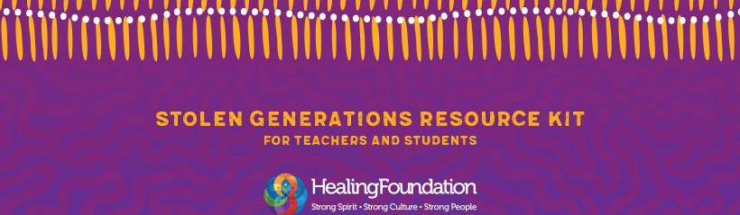
School micro grant funding guidelines
March 2019
The Healing Foundation is proud to announce this exciting grants initiative for schools as part of the launch of our new Stolen Generations resource kit for teachers and students.
The kit has been created to help educate young people about Aboriginal and Torres Strait Islander history and culture and the Stolen Generations.
It will make it easy for schools to start conversations and inform classroom discussions using facts and real stories.
The kit includes lesson plans and resources for Foundation Year through to Year 9 as well as professional development tools for teachers.
It was developed by The Healing Foundation in consultation with Stolen Generations members, teachers, parents and curriculum writers and inspired by Stolen Generations members who wanted to see information about this part of Australia’s history embedded in the curriculum across the country.
The Healing Foundation is a national Aboriginal and Torres Strait Islander organisation that partners with communities to address the ongoing trauma caused by actions like the forced removal of children from their families. We work with communities to create a place of safety, providing an environment for Stolen Generations members and their families to speak for themselves, tell their own stories and be in charge of their own healing. Our work helps people create a different future.
These micro grants enable schools to apply for funding of up to $700 to run activities about the Stolen Generations based on the new resource kit during National Reconciliation Week and NAIDOC Week 2019.
My hope is that this funding will assist your school to build knowledge about our Stolen Generations members and our history, as an important foundation for ongoing healing.

To view or download the kit visit www.healingfoundation.org.au/schools

Regards

Richard Weston
Chief Executive Officer

Funding criteria
- Funding is available for schools to conduct activities related to the Stolen Generations resource kit for teachers and students. Activities from the kits include storytelling and text analysis, music and dance sessions, art and video responses, interviews with Elders, group research projects, writing and designing infographics, and poetry writing and performing. Please access the schools kit at www.healingfoundation.org.au/schools.
- Activities must be held within the period of 1 May to 14 July 2019.
- Schools in every state and territory are eligible to apply.
- Activities should engage at least one member of the Stolen Generations.
- Grants of up to $700 are available. Funding is a one off payment and is not available for capital, staffing or ongoing expenses or other school activities/expenses.
- Examples of eligible costs:
- catering
- Stolen Generations support
- cultural performances
- videography/photography
- material related to activities such as art materials

- Partial funding towards activities may be offered in some cases.
- Successful applicants will need to provide their ABN and bank account details.
- Lodging an Expression of Interest (EOI) form does not guarantee your activity will be funded. A selection process will be undertaken and all applicants will be informed of the outcome by email.
- Successful applicants will be required to liaise with The Healing Foundation in promoting funded activities through media and social media. This could include providing images, a contact for media enquiries and promoting the event on social media.
- Where possible successful applicants must provide material from activities to The Healing Foundation such as photos/videos, as well as notify us of any media coverage. The Healing Foundation is committed to the safety of children and understands that it may not be appropriate to provide photos/videos in all cases. In these instances please provide alternative materials such as reflections from students, a brief report from the teacher or other as appropriate (please ensure you outline this in your EOI form).
- Consent forms are to be completed and returned with materials that include any images or voices of students (The Healing Foundation consent form template will be provided).
- Working with children requirements and guidelines for your state/territory must be met and/or followed.
- Successful applicants will be required to complete the reporting requirements and financial acquittal by 16 August 2019. Reporting and acquittal is an essential component of the grant. Failure to complete these requirements by the due date may exclude the applicant from applying for future funding.

Applying for funding
To apply for funding please complete the Expression of Interest form provided and return to The Healing Foundation by close of business 10 April 2019.

Please contact The Healing Foundation on 02 6272 7500 or funding@healingfoundation.org.au if you have any questions.

Please note that activities must be undertaken within the period of 1 May to 14 July 2019.

NO EXTENSIONS WILL BE POSSIBLE.
Please ensure before applying that your school has the capacity to run the activities in this time period and report on all activities within the required timeframe.

For further information about The Healing Foundation, our work and resources, please visit www.healingfoundation.org.au

